Database Management Guide
1. Basic DB Connection
Command to connect to DB:
sqlplus Username/Password@DB_INST
Example:
sqlplus SINAPP11/SINAPP11@abp3t
2. Login to DB Server
Command:
ssh oracle@db_server
Example:
ssh oracle@indlin7131
Password: 4Getit$
3. Check DB Logs
Navigate to: cd /oravldp/ORACLE
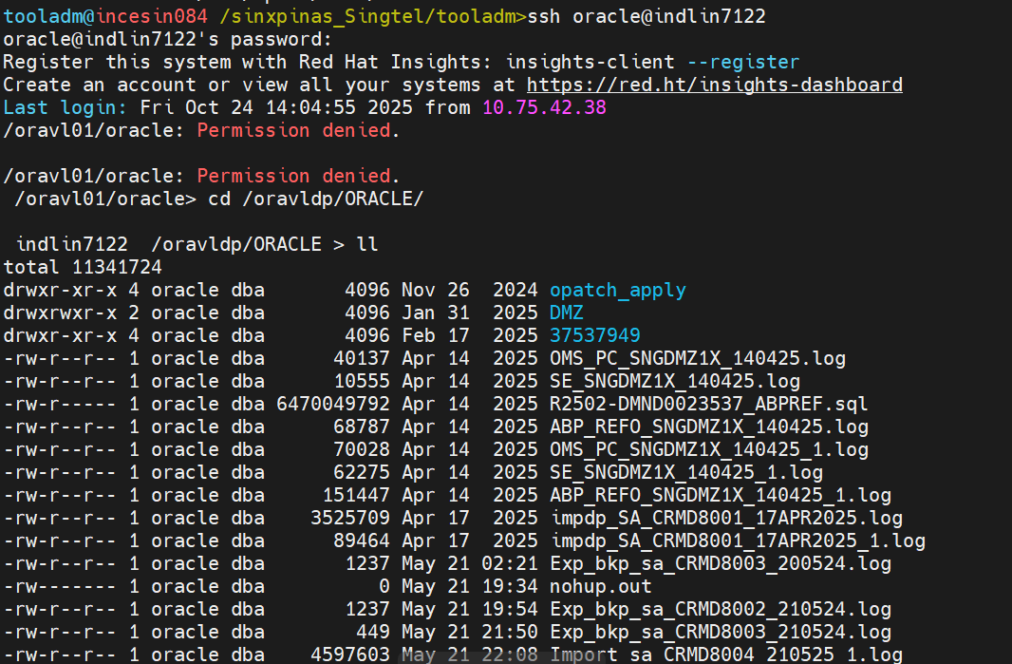
4. Check DB Host Using DB Instance
Command:
tnsping DB_INST
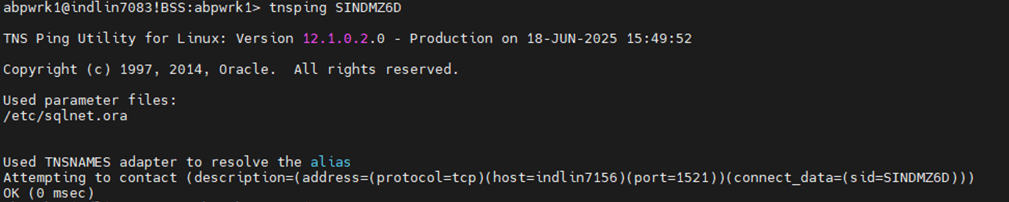
5. Manage Listener
Check Listener Status:
lsnrctl status
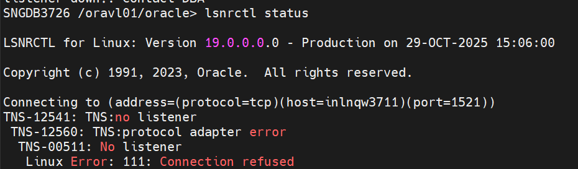
Start Listener:
lsnrctl start
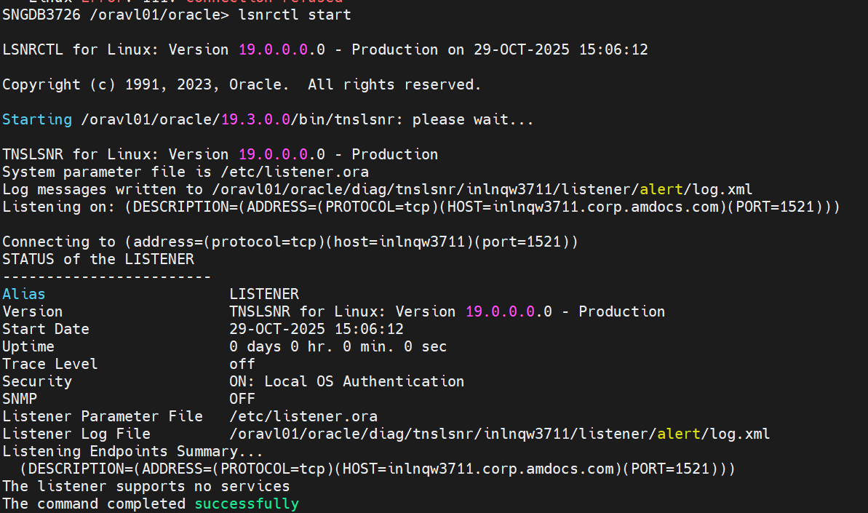

7. Make DB UP
Check DB Status First.
Command:
ckup
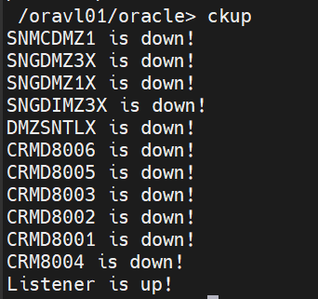
If DB is down:
sett DB_INST
orasql
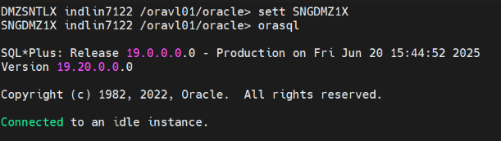
If above fails:
setenv ORACLE_HOME /oravl01/oracle/19.3.0.0
setenv PATH ${ORACLE_HOME}/bin:${PATH}
setenv ORACLE_SID DB_INST
sqlplus / as sysdba
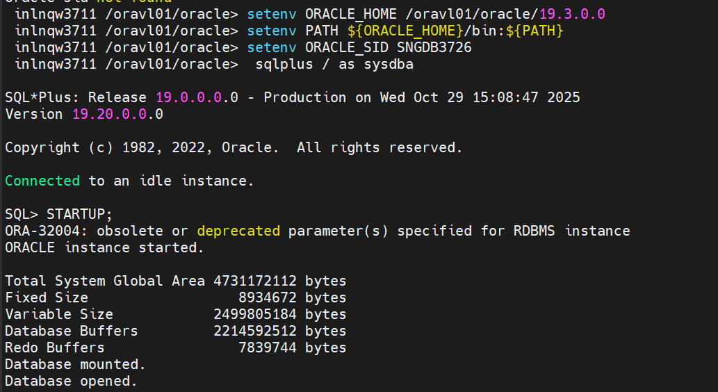
8. Apply MEC Dumps Manually
🔹 Step 1: Connect to Destination DB Server
Navigate to:
cd /oravldp/ORACLE
If not available:
cd /XPISTORAGE/oradp/SINGTELPMX/ORACLE
🔹 Step 2: Take Backup of Users
- Users: ABPREFO1, OMS1PCOWN, SE1SEOWN
🔹 Export Command Format (To take backup)
expdp <user>/<password>@DEST_DB_INST directory=DPDIR dumpfile=<dumpfile>.dmp logfile=<logfile>.log EXCLUDE=statistics
Examples:
expdp ABPREFO1/ABPREFO1@SNGDMZ1X directory=DPDIR dumpfile=SNGDMZ1X_expdp_ABP_040925_bkp.dmp logfile=SNGDMZ1X_ABP_expdp_040925_bkp.log EXCLUDE=statistics
expdp OMS1PCOWN/OMS1PCOWN@SNGDMZ1X directory=DPDIR dumpfile=SNGDMZ1X_expdp_OMS_040925_bkp.dmp logfile=SNGDMZ1X_OMS_expdp_040925_bkp.log EXCLUDE=statistics
expdp SE1SEOWN/SE1SEOWN@SNGDMZ1X directory=DPDIR dumpfile=SNGDMZ1X_expdp_SE_040925_bkp.dmp logfile=SNGDMZ1X_SE_expdp_040925_bkp.log EXCLUDE=statistics
9. Import MEC Dumps
🔹 Import Command Format
impdp <user>/<password>@DEST_DB_INST directory=DPDIR dumpfile=<dumpfile>.dmp logfile=<logfile>.log TABLE_EXISTS_ACTION=TRUNCATE CONTENT=DATA_ONLY REMAP_SCHEMA=Source_User:<user>
Examples:
impdp ABPREFO1/ABPREFO1@SNGDMZ1X directory=DPDIR dumpfile=SNG65_expdp_ABP_SNGDBO65_SNGABP2X_Tue26Aug2025_123116.dmp logfile=SNG65_ABP_SNGDBO65_SNGABP2X_04Sept2025_0103_impdp.log TABLE_EXISTS_ACTION=TRUNCATE CONTENT=DATA_ONLY REMAP_SCHEMA=SNGDBO65:ABPREFO1
impdp OMS1PCOWN/OMS1PCOWN@SNGDMZ1X directory=DPDIR dumpfile=SNG65_expdp_OMS_SNG65_SNGOMS2X_Tue26Aug2025_124551.dmp logfile=SNG65_OMS_SNG65_SNGOMS2X_04Sept2025_1225_impdp.log TABLE_EXISTS_ACTION=TRUNCATE CONTENT=DATA_ONLY REMAP_SCHEMA=SNG65:OMS1PCOWN
impdp SE1SEOWN/SE1SEOWN@SNGDMZ1X directory=DPDIR dumpfile=SNG65_expdp_SE_SNG65SE_SNGOMS2X_Tue26Aug2025_072939.dmp logfile=SNG65_SE_SNG65SE_SNGOMS2X_04Sept2025_1225_impdp.log TABLE_EXISTS_ACTION=TRUNCATE CONTENT=DATA_ONLY REMAP_SCHEMA=SNG65SE:SE1SEOWN

